Lesson 4.1- The Atomic Model
This unit starts with an investigation of the atom, and how different ways of thinking about the model have been used in chemistry over its existence as a science. We’ll go back to the origin of chemistry and then move through some of the major models. Along the way we’ll learn some (hopefully) interesting things

The Dalton Model
For most of it’s history as a science, chemistry used a model of the atom that we retrospectively named the Dalton model, in honour of English chemist John Dalton, who did some experimental work in the late eighteenth century that demonstrated that atoms actually do exist in a way that lets us think of them as discrete particles (which was still an open question at the time). The Dalton model treats atoms as tiny, indestructible spheres of mass. Dalton acknowledged that there were different types of atoms, which we call elements. Dalton could observe that different elements have different masses and different ways in which they react with other atoms, but his model doesn’t really explain why different types of atoms have different masses. Here’s an illustration of what the Dalton model looks like:

If this looks familiar, it’s because the Dalton model is the model of atoms that we have been using in all of our particle diagrams in this course to this point in time.

The Bohr Model
The Dalton model was pretty much the operating model of the atom for about 100 years. But then some advances in experimental technology allowed chemists to deduce the existence of smaller, subatomic particles. The first subatomic particle to be discovered was the negatively charge electron (discovered by J.J. Thomson). Pretty shortly thereafter, the positively charged proton was discovered by Ernest Rutherford in this very cool, very famous, experiment. Finally, the neutral neutron was discovered by James Chadwick in 1932. But even before the discovery of the neutron, Niels Bohr had revised the model of the atom to agree with all of the experimental data that was being gathered, and arranging it into a model of the atom that we call the Bohr model. Here’s what the Bohr model looks like:

There are a few important notes about the Bohr model:
- The Bohr model explains where the mass of an atom comes from. Almost all of the mass (99.999% of it) is due to the protons and neutrons of the atom, which are localised to a region in the center of the atom called the nucleus. Protons and neutrons have essentially the same mass, which we have defined as 1 atomic mass unit (a.m.u.). So if an atom has 6 protons and 6 neutrons, it has a mass of 12 atomic mass units (a.m.u.’s).
- The electrons, with a tiny smidgeon of mass that we never pay attention to, are found outside of the nucleus in regions that are variously called electron shells, principle energy levels, or even the electron cloud. Each principle energy level can fit a specific number of electrons.
- To account for the different charges of the different subatomic particles, we assign every proton a charge of +1, every electron a charge of -1 and every neutron a charge of 0.
- The Bohr model also explains why most atoms engage in chemical bonds with other atoms. It involves an interaction of electrons. But not all electrons are easily bonded. Only the electrons in the outermost principle energy level of an atom can interact with the electrons of other atoms. Because of the central importance of this outermost level of electrons, we give it a special name: the valence.
- Even if an atom has valence electrons, it may not bond them with other atoms. Atoms will only bond to complete their valence electron level. For almost every atom, this means they have 8 valence electrons. This “8 electrons in the valence” thing is such a big deal that we call it the Octet Rule.

New Skill: Determining the number of subatomic particles in an atom.
We use the Bohr model of the atom to figure out the number of protons, neutrons, and electrons in an atom. Every element has a unique number of protons. This number— called the atomic number— is also the number order by which elements are listed on the Periodic Table. So if we know the element that we are analyzing that gives us the number of protons that any atom of that element has. Let’s look at an example element: Lithium. The atomic number of lithium is 3, which means that lithium has 3 protons. Any non-bonded atom of an atom is going to have an equal number of electrons to protons, because unbonded atoms have a neutral charge. In the case of lithium, there will be 3 electrons to balance out the 3 protons.
Determining the number of neutrons is a little trickier. In order to do it, we need to know the atomic mass of the atom in question. This is complicated by the fact that different atoms of the same element can have different numbers of neutrons. But generally most of the atoms of an element will all have the same number of neutrons. In any event, you need to be given the mass of the atom (or be taught how to get it from the periodic table). Once you know that, you can simply subtract the atomic number from the atomic mass in order to get the number of neutrons. The most common mass for lithium is 7a.m.u’s so those atoms of lithium have 4 neutrons (7 - 3). Generally, we write the information related to an atom’s composition in a format called A/Z notation.

Sometimes, we even get rid of the atomic number in our notation, and just write it like as <Element Symbol>-{Mass #}. For a lithium atom with 4 neutrons, this would be written as Li-7.

New Skill: Lewis Dot Diagrams
Because the only electrons involved in bonding are valence electrons, those are frequently the only ones that we want to focus on. This fact was used by Gilbert Lewis in the 1940’s to popularize the Lewis Dot Diagram for atoms. Lewis dot diagrams are really easy. You put the symbol for the element, and surround it with a number of dots that equal its number of valence electrons. Here are the dot diagrams for the elements Lithium, Beryllium, Boron, Carbon, Nitrogen, Oxygen, Fluorine, and Neon:
When writing a Dot Diagram, adhere to the following rules:
- No more than two dots on a side.
- Technically, we put the first two dots on the top of the symbol and then fill in the rest in a clockwise orientation.
- If you ever have more than 8 dots, you have done something wrong.

The Modern Atomic Model
While we won’t use it in this class for much of anything, you should be aware that the model of the atom has developed beyond the Bohr model. The modern atomic model reflects our most accurate understanding of the atom. The major differences between the Bohr model and the modern atomic model include:
- The location of electrons: Instead of existing in circular regions surrounding the nucleus, electrons are actually located in complicated 3D regions of space called orbitals. But we can’t actually ever know where an electron both is, and where it is going simultaneously, so these regions are really just statistical probability spaces where we would be likely to find electrons.
- The nucleus is very, very, small compared to the radius of the electron cloud. How small? Think of a blueberry, suspended in space, in the middle of the auditorium. The blueberry is the nucleus, and the auditorium walls are the radius of the electron cloud. Crazy, right?
You’re not going to ever need to use the modern model of the atom, but you should still know it exists. This is the thing about models, they are useful for different purposes, and they illustrate different aspects of reality. None of the earlier models of the atom are “wrong” anymore than the modern model is “right”. They’re just useful for different ways of thinking about atoms. Which is totally fine.

For Your Consideration:
- Go find a bunch of elements and for each one, do the following:
  - Determine the number of protons, electrons, and neutrons.
  - Represent the atom in A/Z notation, as a Bohr Diagram and as a Lewis Dot Diagram.
  - Figure out the easiest way for the element to fulfill the Octet Rule (will it gain electrons? Lose them? How many?)

Lesson 4.2- The Periodic Table
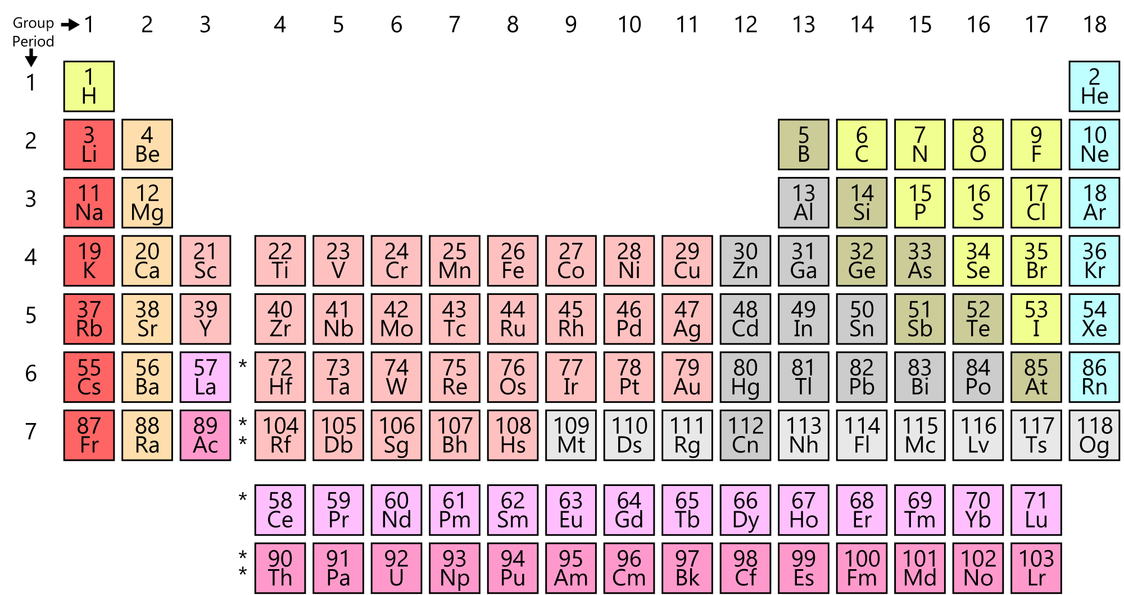
Since we have a handle on atoms from the first lesson in this unit, we can now start to understand why this thing looks the way it does:
This is the Periodic Table, an early version of which was proposed by Dimitri Mendeleev, before being refined by a bunch of other scientists into the modern version that you see above.
Writing/reading notes about the periodic table is kind of a boring way to get a handle on one of the coolest diagrams ever. So instead, let’s try something different for these notes. Watch the videos that I’ll list below, play around with some of the linked resources, and then take a look at the Consideration Questions. If you can answer them all, you understand what you need to understand here.
Crash Course Chemistry Videos: | K-Chem Videos:
- The Periodic Table | - Tour of the Periodic Table  - Periodic Trends
Linked Resources:
- Dynamic Periodic Table
- Photographic Periodic Table
- RSC Periodic Table

For Your Consideration:
- Make sure you can identify elements as:
  - Metals/Metalloids/Non-Metals
  - Solids, Liquids, and Gases at Room Temperature (298K) and Standard Temperature.
  - All elements that belong to the following groups:
    - Alkali Metals
    - Alkaline Earth Metals
    - Transition Metals
    - Halogens
    - Noble Gases
- In terms of atomic structure:
  - What does each member of a group have in common?
  - What does each member of a period have in common?
  - How and why does atomic radius change in a group? How and why does it change in a period?
  - How and why does electronegativity change in a group? How and why does it change in a period?
  - How and why does first ionization energy change in a group? How and why does it change in a period?
  - What metals are the most reactive? Why?
  - What non-metals are the most reactive? Why?

The remaining, internal, non-valence electron levels are called the kernel.
The only exception to this rule are the first few elements on the periodic table. These elements only fill their first energy level, which fits a total of 2 electrons.
We call atoms of the same element with different numbers of neutrons isotopes.
I won’t care if you forget this order, but you’ll impress me if you remember.
Also variously referred to as the Wave-Mechanical model, or the Quantum-Mechanical model.
Don’t blame me for this brain-buster, blame this guy.

